Final project report Native mobile
Fitness App (SwiftUI + HealthKit)
Group SE -2405
Members: Ramazan Talgatov, Daniyar Kairatov , Nuraly Abat,
Ahmetov Rasul

Project Overview
The Fitness App is an iOS application developed using SwiftUI and following the MVVM (Model–View–ViewModel) architecture pattern.
The purpose of the application is to help users:
- Track workouts
- Monitor daily health statistics (steps, calories, heart rate)
- Maintain a workout streak
- Complete daily fitness challenges
- Unlock achievements
- Visualize workout progress using charts
The app integrates with Apple HealthKit to fetch real health data and uses UserDefaults for local persistence

Application Architecture
The project follows the MVVM architecture, which separates responsibilities into three layers:
2.1 Model Layer
Contains pure data structures:
- Workout
- Exercise
- WorkoutProgress
- Achievement
- Challenge
- WorkoutType
These models:
- Conform to Identifiable
- Some conform to Codable
- Contain no UI logic
- Represent business data only
This ensures clear separation of concerns.

2.2 ViewModel Layer
ViewModels manage business logic and data flow:
- HealthViewModel
- ChallengeViewModel
- AchievementsViewModel
- ProgressViewModel
- StatisticsViewModel
- TimerViewModel
- WorkoutStore
- StreakManager
Responsibilities:
- Data processing
- State management using @Published
- Communication with services
- Persistence handling
- Business logic (streak calculation, challenge generation)
They conform to ObservableObject and use Combine.

2.3 View Layer
Views are built entirely using SwiftUI:
Examples:
- WorkoutListView
- WorkoutDetailView
- StatisticsView
- AchievementsView
- HealthStatsView
- ChallengeCard
- WorkoutCard
- GlassCard
Views:
- Use @StateObject, @EnvironmentObject
- Reactively update based on state changes
- Contain only UI logic

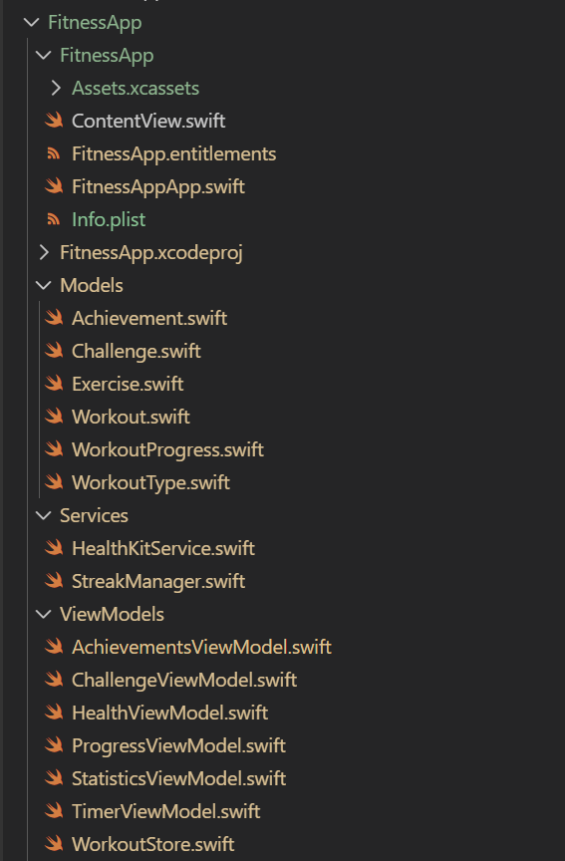

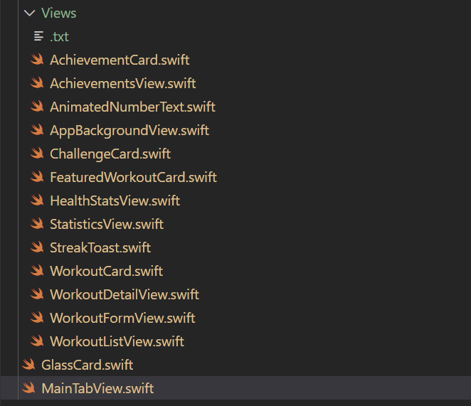

HealthKit Integration
The app integrates with Apple HealthKit using: HealthKitService
Features:
- Request user authorization
- Fetch today’s steps
- Fetch active calories
- Fetch latest heart rate
- Use HKStatisticsQuery
- Use HKSampleQuery
Privacy permissions are correctly configured in:
- Info.plist
- FitnessApp.entitlements
This ensures compliance with iOS privacy requirements

Core Features ->
Workout Management
Handled by: WorkoutStore
Features:
- Add workout
- Edit workout
- Delete workout
- Persist workouts using UserDefaults
- Filter workouts by type
- Display featured workout
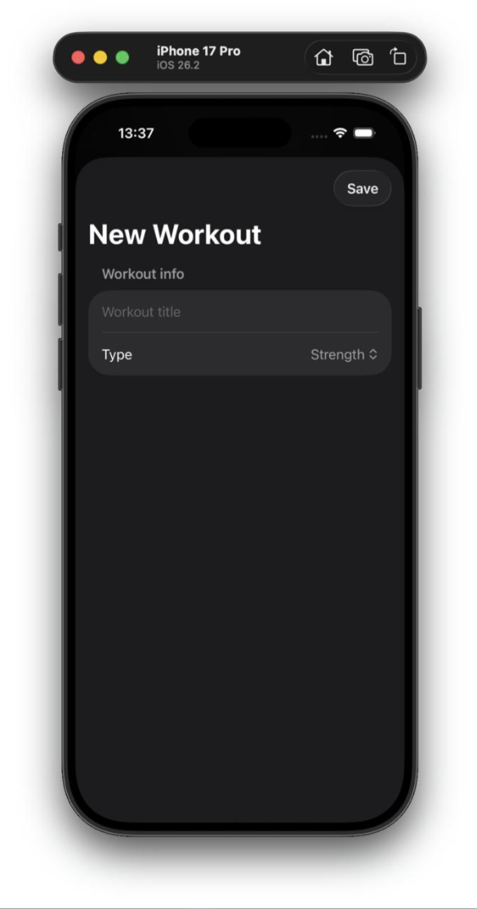
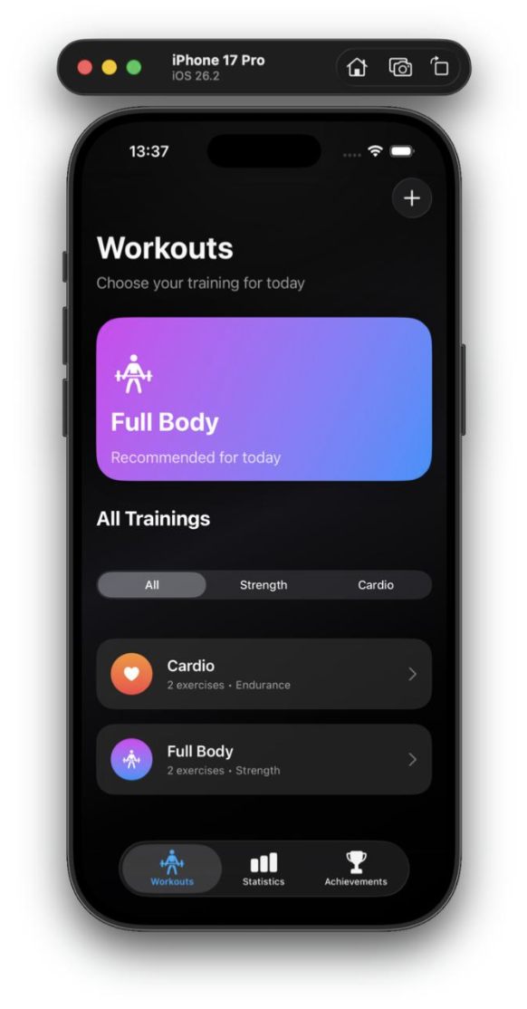
Workout Detail & Timer
Implemented in:
WorkoutDetailView
TimerViewModel

Features:
- List exercises
- Start/Stop timer
- Global timer display
- Finish workout button
- Add workout to progress
- Update streak
- Show streak toast animation
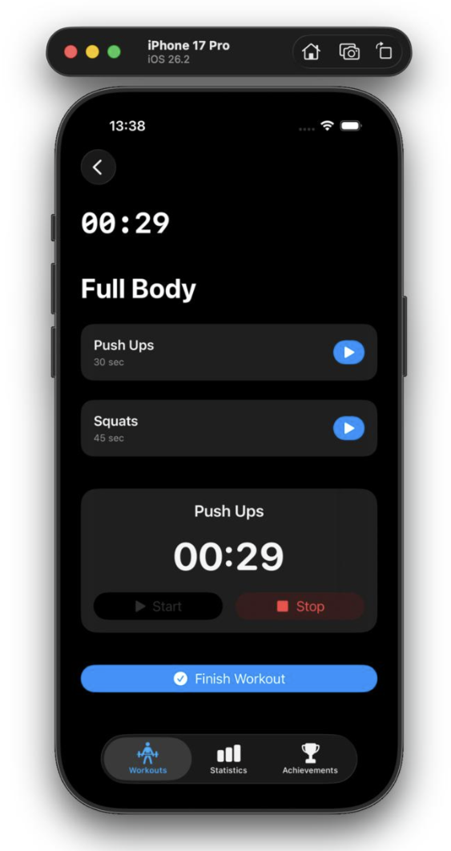
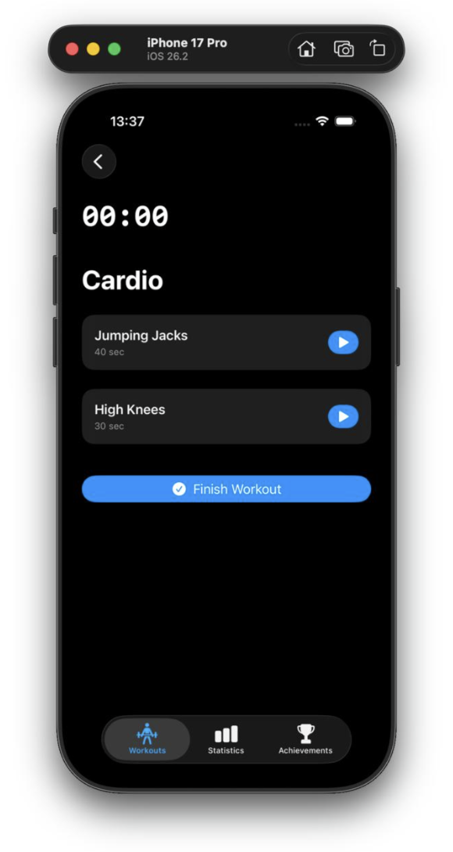
Streak System
Implemented in: StreakManager
Logic:
- Compares last workout date
- Increments streak if consecutive days
- Resets if gap > 1 day
- Saves in UserDefaults
This feature increases user engagement and consistency

Achievements System
Implemented in: AchievementsViewModel
Achievements:
- First Workout
- 3-Day Streak
- 7-Day Streak
Unlocked dynamically based on streak

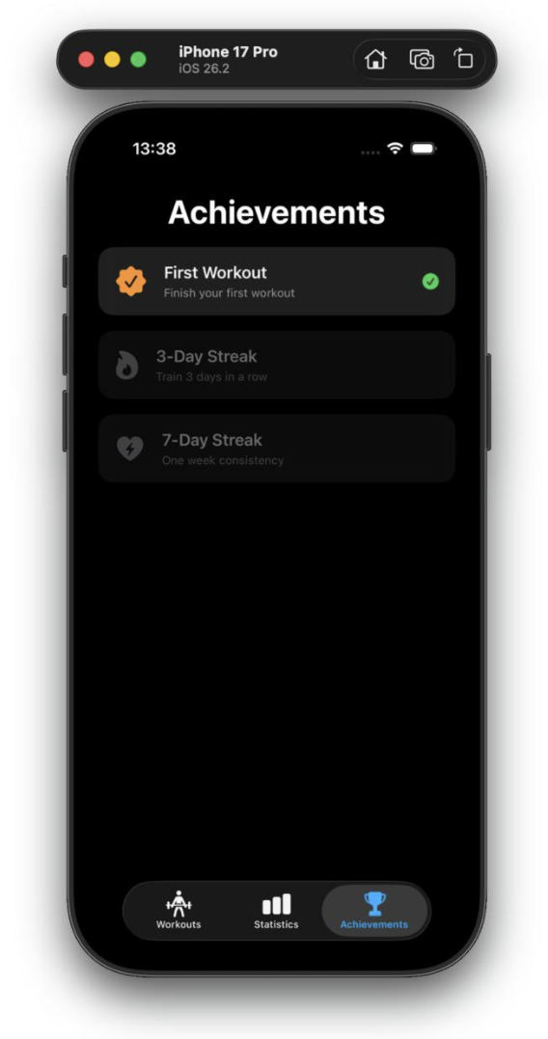
Daily Challenges
Implemented in:ChallengeViewModel
Challenges:
- 10,000 steps
- Burn 300 kcal
- Check heart rate
- Finish workout
Generated based on HealthKit data.

Statistics & Charts
Implemented using: Charts framework
Features:
- Line chart of workout progress
- Animated chart rendering
- Total workouts counter
- Random demo stats for safe testing
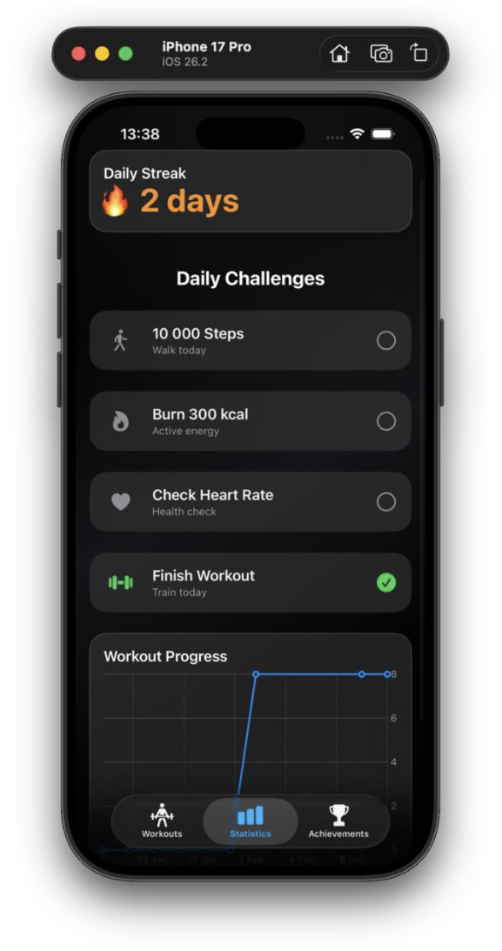
Data Persistence
The app uses:
UserDefaults for:
- Workout list
- Workout progress
- Daily streak
JSONEncoder / JSONDecoder for:
- Encoding Workout
- Encoding WorkoutProgress
Advantages:
- Lightweight
- No external database required
- Simple implementation

UI & Design System
The app uses modern SwiftUI design:
- Glassmorphism (.ultraThinMaterial)
- Gradients
- Custom reusable components
- Animated numbers
- Toast notifications
- Spring animations
- Dark gradient background
Reusable UI components:
- GlassCard
- AchievementCard
- ChallengeCard
- WorkoutCard
This improves maintainability and consistency

State Management
Used property wrappers:
- @State
- @StateObject
- @ObservedObject
- @EnvironmentObject
- @Published
Data flow:
- App injects global state via environmentObject
- ViewModels update state
- Views automatically re-render

Cards
Section of each integrated features
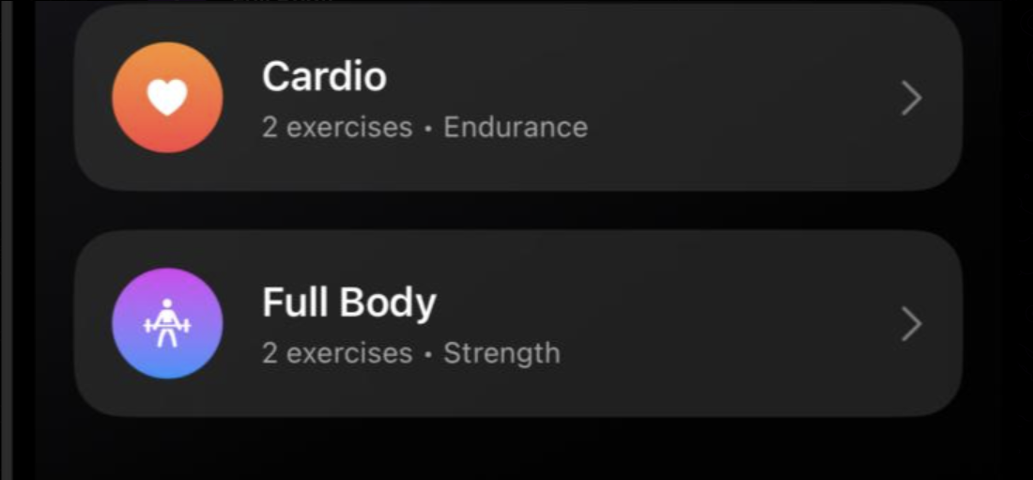
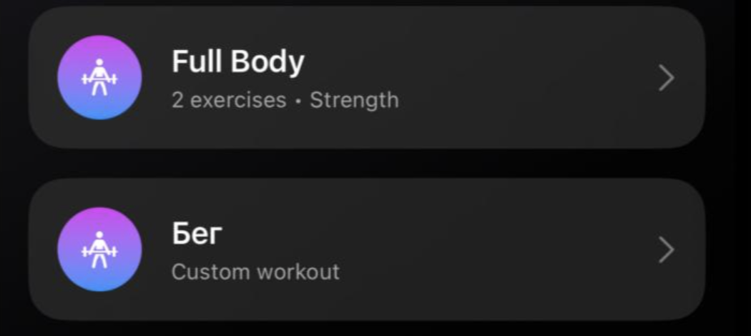
Also available to Edit/Delete
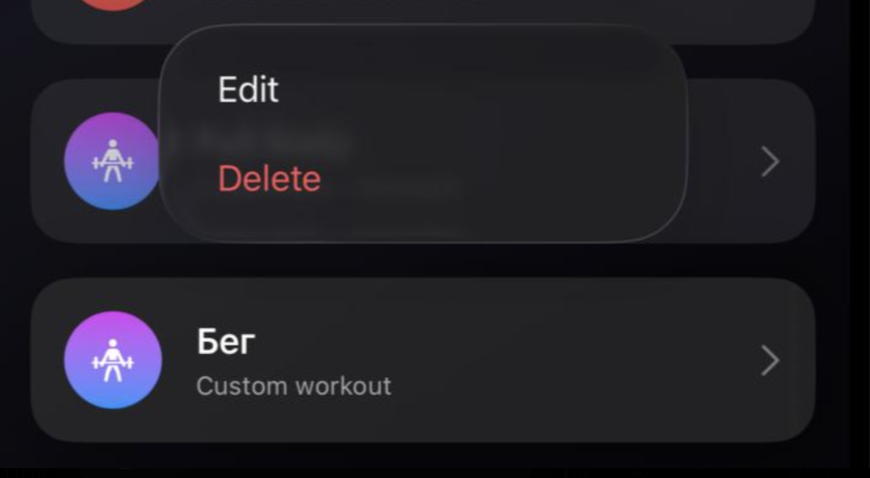

Conclusion
The Fitness App is a well-structured iOS application developed using SwiftUI and the MVVM architecture. It integrates HealthKit to retrieve real health data, uses Charts for progress visualization, and stores data locally with UserDefaults.
The app combines workout tracking, health monitoring, streak calculation, and achievements to motivate users and encourage consistency. The project demonstrates proper architecture design, reactive state management, and modern UI implementation.
Overall, the application represents a functional and scalable fitness tracking prototype built according to modern iOS development standards

